Order No: 34 of 2025
Dated: 30-06-2025

Subject: Reassignment of Duties.

In the interest of administration and to ensure seamless operational continuity,
This directive is to facilitate his assignment to further duties as deemed necessary by the Incharge Estates, effective from the date of this order.

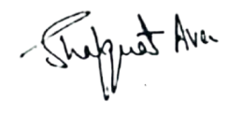

No: KGP/Estt/2025/486-487
Dated:30-06-2025
Dr. Shafquat Ara
Principal
Kashmir Govt.Polytechnic College Srinagar

Copy to:
- Incharge Estates for information.
- Concerned official for compliance.

